

Assignment 3

CPSC 583: Introduction to Information Visualization

Edrienne Manalastas

# Data Summary #1

# ../../../../../Desktop/Screen%20Shot%202017-12-04%20at%209.28.05

# Figure 1. A data summary of the obesity poverty ratings in the US per state.

# Data Summary Justification

To create this data summary, I chose one year and one stratification to visualize. This is because I am planning to use this summary to sketch the different obesity values per state in the country. I chose not to manipulate the data (summation, average calculation, etc), since there is no need to do so when I am just using the data per state. I chose to remove columns such as Year_End, LocationAbbr, Total, Age(years), Education, Gender, Income, Race/Ethn, and StratificationCategorizationId1 since they were either unnecessary or redundant.

# Data Summary #2

|  |  |  |  |  |  |  |  |  |  |
| --- | --- | --- | --- | --- | --- | --- | --- | --- | --- |
| Brand | mfr | Type | calories | carbo | fat | fiber | potass | protein | rating |
| All-Bran | Kellogg | Health | 70 | 7 | 1 | 9 | 320 | 4 | 59.425505 |
| Bran Chex | Ralston | Regular | 90 | 15 | 1 | 4 | 125 | 2 | 49.120253 |
| Bran Flakes | Post | Health | 90 | 13 | 0 | 5 | 190 | 3 | 53.313813 |
| Cheerios | General Mills | Kids | 110 | 17 | 2 | 2 | 105 | 6 | 50.764999 |
| Corn Flakes | Kellogg | Regular | 100 | 21 | 0 | 1 | 35 | 2 | 45.863324 |
| Cream of Wheat (Quick) | Nabisco | Health | 120 | 21 | 0 | 1 | 1 | 3 | 64.533816 |
| Crispix | Kellogg | Health | 110 | 21 | 0 | 1 | 30 | 2 | 46.895644 |
| Frosted Mini-Wheats | Kellogg | Kids | 100 | 14 | 0 | 3 | 100 | 3 | 58.345141 |
| Grape Nuts Flakes | Post | Health | 100 | 15 | 1 | 3 | 85 | 3 | 52.076897 |
| Grape-Nuts | Post | Health | 110 | 17 | 0 | 3 | 90 | 3 | 53.371007 |
| Great Grains Pecan | Post | Health | 120 | 13 | 3 | 3 | 100 | 3 | 45.811716 |
| Life | Quaker | Diet | 100 | 12 | 2 | 2 | 95 | 4 | 45.328074 |
| Maypo | Homestat | Regular | 100 | 16 | 1 | 0 | 95 | 4 | 54.850917 |
| Nutri-grain Wheat | Kellogg | Health | 90 | 18 | 0 | 3 | 90 | 3 | 59.642837 |

Figure 2. A data summary of the cereal data

# Data Summary Justification

To create this data summary, I based it on the ratings. I took the top 5 and bottom 5 ratings along with the average ratings. My goal is to sketch nutrients relative to calories, so I removed the unrelated columns such as whether the cereal is hot/cold, cups, % from sugar and % from fat.

# Report

## Why Visualize This Data?

The data given is composed of different perspectives that show the obesity ratings per US state along with data that can show possible correlations. The first two sheets were on the cereal data along with each state’s favourite cereal. The last two are composed of data involving the overall obesity rate, overweight rate, healthy rate, exercise rate, and poverty rate in each US state. It also has an obesity rate per stratification.

It is important to visualize this data since it allows us to understand the trends more easily and to better see the relationships in the data given. Rather than looking at an Excel sheet and comparing values individually, visualizing the data helps the viewer get an overall idea of the data and its trends.

## Chosen Sketch

As I was doing my sketches, I learned that some stratifications have a higher overall obesity rate like the Non-Hispanic Black group. Moreover, some stratifications had a lower overall obesity rate such as the Asian group. I chose to visualize the information in this way to see more stratification trends per year.

## Directions and Change

One of the hardest considerations while doing this visualization was whether I should add the state name labels automatically or if the state names would appear on hover. It would be more visually pleasing to show it on hover, but it is more quickly understood when the labels are printed on default (especially for non-Americans like me). However, when I tried to add the labels automatically, this is what the map looked like:

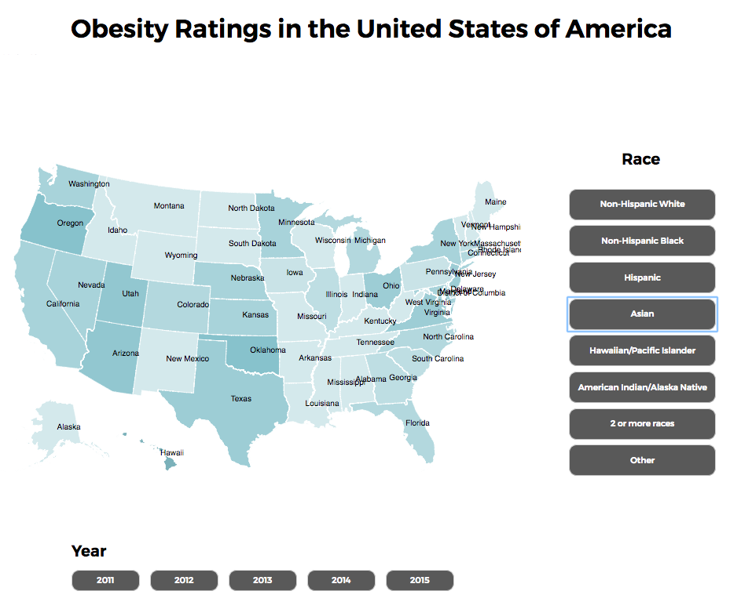

As you can see, it is hard to distinguish some states from the others since they are very close. Adjusting each text would be tedious and still hard to discern, so I chose to show the labels on hover. Another reason why is because some of the colours used to show the degree of obesity in one state are dark, so the text would not show. If I used a lighter colour, it would then blend into the lighter states. At the same time, if I surrounded the text by a frame, it would make the map look bulky. Therefore, I chose to show state name by hover.

## Representation

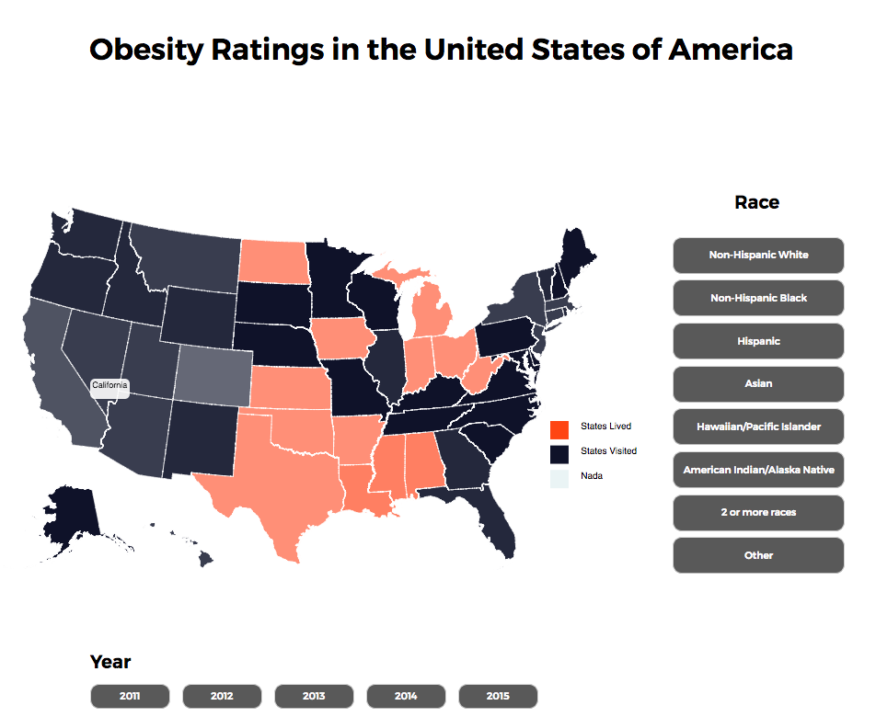

Each colour is based on the Data_Value column in the ObesitySurveyMultiYear sheet

All stratifications included in the visualization are from the ObesitySurveyMultiYear sheet

Depending on the year, different data is shown to the viewers

## Presentation

As mentioned in the changes & decisions section, I chose to show the US states’ names on hover instead of showing them all automatically. This is because doing so make the visual look cluttered and messy. I want to show the map in a simple and understandable way. Moreover, I also ensured that I was not showing too much information at the same time to the viewer. I chose to only show the obesity rating per state instead of showing five more variables which could possibly confuse the viewers.

## Interaction

When the viewer hovers on a state, the opacity changes and the state’s name is shown. The viewer can also change the year and the stratification.

## Positive Features

The main purpose of this visualization is to help viewers see the stratifications which have a higher rate of obesity and to see which states have a high degree of obesity. A positive trait of this visualization is its simplicity and ease in seeing the obesity ratings per stratification, and how the map visual allows the reader to compare the obesity ratings per state. It also allows the viewer to see how the obesity ratings have changed from 2011 to 2015.